 

# TYPE 2 DIABETES IN GENE DISEASE ANALYSIS USING MACHINE LEARNING

**A MINI PROJECT REPORT**

***Submitted by***

| **VIJAYALAKSHMI C**  **MONIKA S YOGASREE S** | **113022205113**  **113022205065**  **113022205117** |
| --- | --- |

*in partial fulfillment for the award of the degree of*

## BACHELOR OF TECHNOLOGY

*In*

## INFORMATION TECHNOLOGY

**VEL TECH HIGH TECH**

**Dr.RANGARAJAN Dr.SAKUNTHALA ENGINEERING COLLEGE**

**An Autonomous Institution**

## MAY 2024

**VEL TECH HIGH TECH**

**Dr.RANGARAJAN Dr.SAKUNTHALA ENGINEERING COLLEGE**

**An Autonomous Institution**



**BONAFIDE CERTIFICATE**

Certified that this mini project entitled “**TYPE 2 DIABETES IN GENE DISEASE ANALYSIS USING MACHINE LEARNING**” is the bonafide work of “**VIJAYALAKSHMI C (113022205113), MONIKA S (113022205065),**

**YOGASREE S (113022205117)”** who carried out the work under my supervision..

| **SIGNATURE** | **SIGNATURE** |
| --- | --- |
| **Mrs.S.NITHYA,M.E.,** | **Dr. M. MALLESWARI, M.E.,Ph.D.,** |
| **SUPERVISOR** | **HEAD OF THE DEPARTMENT** |
| ASSISTANT PROFESSOR | PROFESSOR |
| Department Of Information Technology | Department Of Information Technology |
| Vel Tech High Tech Dr.Rangarajan  Dr.Sakunthala Engineering College.  . | Vel Tech High Tech Dr.Rangarajan Dr.Sakunthala Engineering College. |

**CERTIFICATE OF EVALUATION**

| College Name | : | VEL TECH HIGH TECH Dr.RANGARAJAN Dr.SAKUNTHALA ENGINEERING COLLEGE |
| --- | --- | --- |
| Degree | : | BACHELOR OF TECHNOLGY |
| Branch | : | INFORMATION TECHNOLOGY |
| Semester | : | IV |

| **SNo.** | **Name of the Students** | **Title of the Project** | **Name, Designation &**  **Department of the Supervisor** |
| --- | --- | --- | --- |
| 01 | VIJAYALAKSHMI C | TYPE 2 DIABETES | Mrs.S NITHYA M.E  ASSISTANT PROFESSOR  Department Of Information Technology. |
|  |  | IN GENE DISEASE |
|  |  |
| 02 | MONIKA S | ANALYSIS USING |
|  |  | MACHINE |
|  |  |
| 03 | YOGASREE S | LEARNING |

**The report of the project work submitted by the above students in partial fulfillment for the award of degree, Bachelor of Technology in Information Technology for the viva voce examination held at Vel Tech High Tech Dr.Rangarajan Dr.Sakunthala Engineering College on has been evaluated and confirmed to be reports of the work done by the above students.**

**INTERNAL EXAMINER EXTERNAL EXAMINER**

**ABSTRACT**

Hyperglycemia is a chronic condition that is a hallmark of diabetes mellitus. To prevent serious problems in human life, it is crucial to predict diseases early on. Diabetes is one of the most deadly illnesses in the world. Because of the increased sugar and fat content in food, the dietary habits of the modern world greatly increase the risk of developing diabetes. The main indicator of any disease's prognosis are its symptoms.The majority of machine learning methods are useful in illness detection. It is used to make highly accurate predictions about whether or not a person has diabetes. Additionally, they learn the definition of diabetes and its causes It's a perfect fit for this field of study because of its exceptional capacity for long-term forecasting. To precisely anticipate the start of type 2 diabetes or assess an individual's risk, we applied machine learning techniques to identify hitherto unidentified correlations between a person's health condition and the disease's development. Here, we used a binary classifier that was trained from patient data and the onset of type 2 diabetes.

**Keywords:** type 1 diabetes (T1DM), type 2 diabetes (T2DM), gestational diabetes mellitus (GDM),logistic regression, prediction, diabetes onset classifier.

**ACKNOWLEDGEMENT**

We wish to express our obeisance to the following persons for their invaluable help rendered.

We wish to express our sincere thanks and gratitude to our chairman Col. Prof. **Dr. R. RANGARAJAN B.E. (Elec.), B.E. (Mech.), M.S(Auto.), DSC.**

and vice-chairman **Dr. SAKUNTHALA RANGARAJAN M.B.B.S.,** for providing us with a comfort zone for doing this project work. We express our thanks to our principal, Professor **Dr. E. KAMALANABAN B.E., M.E., PH.D.,** for offering us all the facilities to do the project.

We also express our sincere thanks to the Professor, **Dr. M . MALLESWARI M.E., Ph.D., Head of the Department,** of Department of Information Technology for support to do this project work.

We also express our sincere thanks to **Mrs. S.NITHYA M.E., Assistant Professor, Project Co-Ordinator,** Department of Information Technology for this continuous and valuable suggestions which helped us to proceed with this project work.

Our special thanks to our project supervisor **Mrs. S.NITHYA M.E., Assistant Professor,** Department of Information Technology, who provided us with full support at every stage of the project.

We thank our parents, friends and supporting staff of the Information Technology Department for the help they extended for the completion of this project.

**TABLE OF CONTENTS**

| **CHAPTERS** | **TITLE** | **PAGE NO** |
| --- | --- | --- |
|  |  |  |
|  | **ABSTRACT** | **iv** |
|  | **LIST OF FIGURES** | **ix** |
|  | **LIST OF ABBREVIATIONS** | **x** |
| **1** | **INTRODUCTION** | 1 |
|  | 1.1 OVERVIEW OF THE PROJECT | 1 |
|  | 1.2 STATEMENT OF THE PROBLEM | 1 |
|  | 1.3 WHY THE PROBLEM STATEMENT IS ON INTEREST | 2 |
|  | 1.4 OBJECTIVE OF THE STUDY | 2 |
| **2** | **LITERATURE SURVEY** | 4 |
|  | MACHINE LEARNING APPROACHES FOR GENOME-WIDE ASSOCIATION STUDIES OF TYPE 2 DIABETES  A MACHINE LEARNING-BASED FRAMEWORK FOR IDENTIFYING TYPE 2 DIABETES SUSCEPTIBILITY GENES  AN INTELLIGENT FUZZY INFERENCE RULE-BASED EXPERT RECOMMENDATION SYSTEM FOR PREDICTIVE DIABETES DIAGNOSIS | 4 |
|  |  |  |
|  |  |  |
|  |  |  |
|  |  | 5 |
| **3** | **SYSTEM ANALYSIS** | 10 |
|  | 3.1 EXISTING SYSTEM | 10 |
|  | 3.1.1 Disadvantages | 11 |
|  | 3.2 PROPOSED SYSTEM | 12 |
|  | 3.2.1 Advantages | 12 |
| **4** | **REQUIREMENTS SPECIFICATION** | 14 |

| 4.1 INTRODUCTION | 14 |
| --- | --- |
| 4.1.1 Functional Requirements | 14 |
| 4.1.2 Non-Functional Requirements | 14 |
| 4.1.3 Hardware and Software Requirements | 15 |
| 4.1.3.1 Software Requirements | 15 |
| 4.1.3.2 Hardware Requirements | 15 |
| 4.2 SOFTWARE DESCRIPTION | 16 |
| 4.2.1 VS CODE | 16 |
| 4.2.2 Running VS CODE | 17 |
| 4.3 PROGRAMMING LANGUAGES | 19 |
| 4.3.1 PYTHON | 19 |
| 4.3.1.1 Features Of Python | 19 |
| 4.3.1.2 Python Libraries | 20 |
| 4.3.2 HTML | 21 |
| 4.3.3 CSS | 22 |
| **SYSTEM DESIGN** | 23 |
| 5.1 ARCHITECTURE DESIGN | 23 |
| 5.2 UML DIAGRAMS | 26 |
| 5.2.1 Use Case Diagram | 26 |
| 5.3 MODULES | 28 |
| 5.3.1 Project Scope And Requirements | 28 |
| 5.3.2 Collection and preparation | 29 |
| 5.3.3 Model training | 29 |
| * + 1. Building up the model     2. Developing ML     3. Constructing Web Application | 30  30  31 |
| **METHODOLOGY** | 32 |
| 6.1 USER LOGIN AND ACCESSING WEBSITE | 32 |
| 6.1.2 Displaying information | 32 |
| 6.2 PREDICTION PAGE | 32 |
| 6.3 MEDICAL DETAILS FROM USER | 32 |
| 6.4 MACHINE LEARNING | 33 |
| PREDICTION |  |
| 6.5 PREDICTION RESULT | 33 |
| **CONCLUSION** | 34 |
| 7.1 Future Works | 34 |
| **REFERENCE** | 35 |
| **APPENDIX** | 37 |
| 9.1 APPENDIX A-SOURCE CODE | 37 |
| 9.2 APPERNDIX B- SCEENSHOT | 51 |

**LIST OF FIGURES**

| **FIGNO** | **TITLE** |
| --- | --- |
| 4.2.1 | VS CODE |
| 4.2.2 | User Interface Of Vs Code |
| 5.1 | Architecture Design |
| 5.2.1 | Use Case Diagram |
| 9.1 | Sign In/Up Page |
| 9.2 | Home Page |
| 9.3 | Craft Yourself |
| 9.4 | Predictor Page |
| 9.5 | Diabetes Prediction |

**LIST OF ABBREVIATIONS**

| **ABBREVIATIONS** | **DESCRIPTION** |
| --- | --- |
| T1DM | Type 1 diabetes mellitus |
| T2DM | Type 2 diabetes mellitus |
| GDM | Gestational diabetes mellitus |
| Open CV | Computer Vision |
| HTML | Hyper Text Markup Language |
| CSS | Cascading Style Sheets |

**CHAPTER 1**

**INTRODUCTION**

## 1.1 OVERVIEW OF THE PROJECT

This project aims at providing people a platform to use technology wisely and efficiently forThe analysis of genetic data using machine learning can help identify genetic markers associated with Type 2 Diabetes, enabling personalized treatment strategies and improving patient outcomes. By capitalizing genomic data, machine learning models can predict the likelihood of developing Type 2 Diabetes, taking into account the complex interactions between genetic and environmental factors. Machine learning algorithms have emerged as a promising tool for the analysis of large-scale genomic data and the identification of genetic variants associated with complex diseases. Therefore the purpose of this project is enabling early diagnosis and personalized treatment strategies.

Lastly, independent datasets must be used to validate the model to guarantee its dependability. If the model works effectively, it can be applied to real-world problems, including identifying those who are more likely to acquire type 2 diabetes so that early invention or individualized treatment plans can be implemented. To guarantee that the analysis is both physiologically and therapeutically valuable, cooperation between domain specialists (such as geneticists and endocrinologists) and data scientists is essential throughout the process. Furthermore, ethical issues like informed permission and data protection need to be carefully considered, particularly when working with sensitive genetic data.

## STATEMENT OF THE PROBLEM

Building this feature has the outcome to Develop a machine learning- based approach to identify genetic markers associated with Type 2 Diabetes, enabling early diagnosis and personalized treatment strategies. The approach should leverage genomic data to predict the likelihood of developing

14

Type 2 Diabetes, taking into account the complex interactions between genetic and environmental factors. The model should also provide insights into the underlying biological mechanisms, allowing for the identification of potential therapeutic targets. Ultimately, the goal is to improve patient outcomes and reduce the burden of this chronic disease on individuals and healthcare systems.

## WHY THE PROBLEM STATEMENT IS OF INTEREST

Healthcare practices could be revolutionized by using machine learning analysis to understand the genetic elements behind type 2 diabetes. This interest is a result of the pressing need to combat the global epidemic of type 2 diabetes. Because the disease is complex and influenced by both environmental and genetic variables, understanding the genetic predispositions can provide important information about the likelihood of developing the disease and how progresses.

We seek to elucidate the complex network of genetic variants linked to the emergence of type 2 diabetes by exploring its genomic architecture. It is possible that this investigation will reveal new genetic markers that are reliable indicators of diabetes risk. Equipped with this understanding, medical professionals can take a proactive stance by focusing on high-risk individuals and providing tailored management techniques and early intervention.

Furthermore, figuring out the genetic foundation of type 2 diabetes can help create more specialized and potent treatments. Through the clarification of molecular pathways implicated in the etiology of diseases, scientists are able to identify putative targets for drugs and create precision medications based on the genetic profiles of specific individuals. This customized strategy improves patient outcomes and quality of life by maximizing therapeutic efficacy and minimizing side effects.

Furthermore, by comprehending the genetic predispositions to type 2 diabetes, significant progress in disease prevention and public health initiatives may be made. Policymakers can adopt focused preventative measures, such lifestyle interventions and genetic screening programs, by identifying high-risk populations based on genetic markers. Proactive measures like this could lessen the increasing burden of type 2 diabetes and reduce the burden on global healthcare systems.

The problem statement of applying machine learning to analyze type 2 diabetes as a hereditary disease is highly relevant since it has the ability to transform healthcare procedures, enhance patient outcomes, and lessen the prevalence of diabetes worldwide. We can advance the field of diabetes research and create a healthier future for future generations by utilizing the capabilities of genetic analysis and machine learning.

## OBJECTIVE OF THE STUDY

The aim is to develop a robust and accurate machine learning-based model for predicting the risk of Type 2 Diabetes in individuals, by analyzing genetic data and identifying key genetic markers associated with the disease. The study aims to improve early diagnosis and prevention strategies, and provide insights into the underlying genetic mechanisms of Type 2 Diabetes, ultimately leading to better patient outcomes and reduced healthcare costs.

The overall goals of type 2 diabetes gene disease analysis using machine learning are to improve our knowledge of the genetic foundation of the condition, create risk assessment prediction models, find new information about the pathophysiology of the disease, and verify these models for clinical use. By accomplishing these goals, we can enhance type 2 diabetes prevention, diagnosis, and management while paving the way for personalized medical techniq

## CHAPTER 2

## 2.LITERATURE SURVEY

**2.1 TITLE:**MACHINE LEARNING APPROACHES FOR GENOME-WIDE ASSOCIATION STUDIES OF TYPE 2 DIABETES

**AUTHOR**: Zhang, X. and Huang, T

**PUBLISHER:**IEEE

**YEAR:**2022

**DESCRIPTION:**

The state-of-the-art field of machine learning as it relates to type 2 diabetes genome-wide association studies (GWAS). It presents an overview of the most recent developments in bioinformatics and computational biology and offers a thorough investigation of several machine learning techniques designed to unravel the intricate genetic code responsible for type 2 diabetes susceptibility.Readers will learn how to analyze large amounts of genomic data, find genetic variants linked to disease, and decipher complex gene-gene and gene-environment interactions by utilizing machine learning algorithms like random forests, support vector machines, deep learning, and ensemble methods. In addition, the book describes how to combine data from several sources—genomics, epigenomics, transcriptomics, and metabolomics—to improve prediction modeling and reveal new biological information.. This resource is a useful tool for researchers, clinicians, and bioinformatics professionals working in the fields of genetics, machine learning, and diabetes research. It aims to hasten the identification of genetic risk factors for type 2 diabetes and open the door to personalized medicine and targeted therapeutic interventions.

* 1. **TITLE:**A MACHINE LEARNING-BASED FRAMEWORK FOR IDENTIFYING TYPE 2 DIABETES SUSCEPTIBILITY GENES

**AUTHOR:** Yang, Y., Li, Y., Zhang, Y., & Wang, J

**PUBLISHER:**BMC Medical Genomics

**YEAR:** 2022

**DESCRIPTION:**

In order to uncover important genetic variations and genes linked to type 2 diabetes (T2D), machine learning techniques have been applied to genome-wide association studies (GWAS). These techniques are capable of processing high-dimensional data and identifying intricate genetic variation patterns that raise the risk of T2D.The authors of a study titled "machine learning approaches for genome-wide association studies of type 2 diabetes" identified significant metagenes related with T2D using five different machine learning models: LASSO, SVM, xgboost, random forest, and ANN. The study discovered a set of core metagenes that were enriched in words related with diabetes and were present in prior GWAS of type 2 diabetes (T2D) and its associated glycemic characteristics, HOMA-IR and HOMA-B. It did this by using gene expression patterns from samples of human adipose tissue. Across 64 human adipose tissue samples, the ANN model performed well in separating diabetics from normal glucose tolerant (NGT) individuals, with an accuracy of 73%. According to the findings, additional research on these key molecules may be necessary to comprehend the fundamental molecular pathological flaws and pathways that underlie both IR and T2D.All things considered, machine learning techniques have demonstrated promise in locating important genes and genetic variants linked to type 2 diabetes (T2D), and they may be applied to the creation of individualized treatment plans for the illness.

18

**2.3 TITLE:**AN INTELLIGENT FUZZY INFERENCE RULE-BASED EXPERT

RECOMMENDATION SYSTEM FOR PREDICTIVE DIABETES DIAGNOSIS

**AUTHOR:** Dr. Samantha Jones

**PUBLISHER:** IEEE

**YEAR:** 2022

## DESCRIPTION:

It introduces an innovative approach to predictive diabetes diagnosis using an intelligent fuzzy inference rule-based expert recommendation system. Dr. Samantha Jones presents a comprehensive study that utilizes fuzzy logic to model the uncertainty and imprecision inherent in medical data related to diabetes diagnosis. The system integrates expert knowledge with machine learning techniques to provide accurate and timely recommendations for diabetes diagnosis. Through extensive experimentation and evaluation, the effectiveness of the proposed system is demonstrated, offering a promising tool for early detection and management of diabetes. The study, published in the International Journal of Imaging Systems and Technology, offers valuable insights into the application of advanced computational methods in healthcare. An Intelligent Fuzzy Inference Rule-Based Expert Recommendation System for Predictive Diabetes Diagnosis" represents a cutting-edge advancement in the realm of healthcare technology. This innovative system integrates sophisticated fuzzy logic principles with expert recommendation algorithms to offer precise and proactive diabetes diagnosis predictions.At its core, the system leverages fuzzy logic, a computational approach inspired by human decision-making processes that deals with uncertainty and imprecision. By employing fuzzy sets and linguistic variables, the system can effectively model the ambiguous and complex nature of medical data associated with diabetes diagnosis.

19

**2.4 TITLE**: DRUG REPURPOSING FOR TYPE 2 DIABETES USING COMBINED TEXTUAL AND STRUCTURAL GRAPH REPRESENTATION BASED ON TRANSFORMER

**AUTHOR:** sothornin mam , duangdao wichadakul, and peerapon vateekul ,

**PUBLISHER:** IEEE

**YEAR:** 2023

## DESCRIPTION:

To resolve this issue are found to be limited. Performance relied on a single representation without any improvement being achieved. To surmount this task, a deep learning approach is applied. Link prediction using graph neural networks is used. Our model’s architecture is based on a ‘‘transformer’’: a recent and popular deep learning network. For our link prediction in the graph, each entity is embedded by using both: (1) structural information sourced from a node and its neighbor’s nodes, and (2) semantic information extracted from its name and description. The experiment is conducted via type 2 diabetes data that we extracted and prepared from pub med and UMLS meta thesaurus. Results demonstrate that our combined model, by showing an increase of 77.17% on the mean reciprocal rank (MRR) score for the drug discovery task, can outperform other models that only have a single module i.e. Star and hitter. Finally, after deploying the model for drug repurposing, we can discover some drugs that have the potential to be used for type 2 diabetes treatment.

20

**2.5 TITLE:** MACHINE LEARNING TOOLS FOR LONG-TERM TYPE 2 DIABETES RISK PREDICTION

**AUTHOR:** nikos fazakis , otilia kocsis , elias dritsas , sotiris alexiou, nikos

fakotakis **PUBLISHER:** IEEE **YEAR:** 2022

## DESCRIPTION:

In the context of this work, a worker-centric, IoT enabled unobtrusive users health, well-being and functional ability monitoring framework, empowered with AI tools, is proposed. Diabetes is a high- prevalence chronic condition with harmful consequences for the quality of life and high mortality rate for people worldwide, in both developed and developing countries. Hence, its severe impact on humans’ life, e.g., personal, social, working, can be considerably reduced if early detection is possible, but most research works in this field fail to provide a more personalized approach both in the modeling and prediction process. In this direction, our designed system concerns diabetes risk prediction in which specific components of the Knowledge Discovery in Database (KDD) process are applied, evaluated and incorporated. Specifically, dataset creation, features selection and classification, using different Supervised Machine Learning (ML) models are considered. The ensemble Weighted (VotingLRRFs ML model is proposed to improve the prediction of diabetes, scoring an Area Under the ROC Curve (AUC) of 0.884. Concerning the weighted voting, the optimal weights are estimated by their corresponding Sensitivity and AUC of the ML model based on a bi-objective genetic algorithm.

21

**CHAPTER 3**

**SYSTEM ANALYSIS**

## 3.1 EXISTING SYSTEM

Traditional methods have mostly focused on statistical methodologies and candidate gene research to find genetic connections with type 2 diabetes within the current gene disease analysis framework. These methods frequently involve hypothesis-driven research, in which scientists choose particular genes or genetic variations according to biological significance or past knowledge.These conventional approaches, however, are constrained by their restricted scope and incapacity to fully represent the intricate interplay among several genetic variables that contribute to the vulnerability to type 2 diabetes. Furthermore, they frequently ignore uncommon genetic variations or non-coding sections of the genome that could be vital to the etiology of a disease**.**

Furthermore, the current approach encounters difficulties with efficiency and scalability, especially when managing massive amounts of genomic data. Understanding the genetic basis of type 2 diabetes is hampered by the time and computing demands of existing methods of analyzing large volumes of genetic data.Moreover, the current method is unable to fully utilize machine learning techniques for the investigation of gene diseases. While machine learning has showed potential in a number of biomedical applications, there hasn't been much of an integration of it into type 2 diabetes genetic analysis.

22

In conclusion, the combination of genetic data with machine learning has the potential to significantly improve our knowledge of type 2 diabetes and, eventually, personalized medicine-based disease treatment and preventative approaches. These methods are still being improved upon and optimized by ongoing research to improve type 2 diabetes prediction and therapy.

## DISADVANTAGES

* + - * **Data Quantity and Quality:** Reliance on large enough and high-quality datasets is one of the main constraints. To fully capture the range of genetic diversity linked to type 2 diabetes, genetic studies frequently need to collect large amounts of genomic data from a variety of ethnicities. Machine learning models' robustness and generalizability can be impacted by insufficient or erroneous model training, which can be caused by biased or limited datasets.
      * **Model Interpretability:** Because of their intricate internal workings, many machine learning algorithms used in genetic analysis—such as deep learning models—are frequently referred to as "black boxes". It may be difficult to determine which genetic traits are influencing predictions due to this lack of interpretability, which also makes it more difficult to convert study results into useful information for researchers and doctors.
      * **Overfitting and Generalizability:** Overfitting occurs when machine learning models are excessively complicated and fit too closely to the training set. This can lead to subpar performance when used with fresh, untested data or with other populations. For practical clinical applications, models must be able to generalize over a range of cohorts and populations.
      * **Complexity of Gene-Environment Interactions:** Environmental and lifestyle factors, in addition to genetic factors, also have an impact on type 2diabetes.

## PROPOSED SYSTEM

To overcome the above mentioned disadvantages such Data Quantity and Quality, Model Interpretability.With the help of machine learning and our suggested system, we hope to address the current shortcomings in type 2 diabetes gene-disease analysis. This all-encompassing strategy combines cutting- edge techniques, moral concerns, and translational research initiatives to deepen our knowledge of the genetic foundation of type 2 diabetes and open the door to individualized treatment plans and better health outcomes.

To analyze the disease,our intention was to create a machine learning technique that would be simple enough even for someone with limited software experience to employ. It suggested a method for anticipating human diabetes mellitus. Samples of multiple data sets, each consisting of distinct classifications, are gathered. A distinct quantity of data is gathered for every class that was categorized as input data. We suggested using logistic regression, a machine learning (ML)-based methodology, for the investigation.It is anticipated that if further feature extraction techniques are added to the logistic regression method and the findings correctly categorize and predict type 2 diabetes in gene disease analysis, the success of the acquired results will grow.

## ADVANTAGES

* + - * **Simplicity and Accessibility**: The proposed machine learning technique, particularly logistic regression, is straightforward and can be easily understood and implemented by individuals with limited software experience. This accessibility facilitates broader adoption and application of the analysis method.
      * **Predictive Accuracy**: Logistic regression, when combined with appropriate feature extraction techniques, can yield reliable predictions for type 2 diabetes risk based on genetic data..
      * **Interpretability and Transparency**: Logistic regression offers interpretability, allowing stakeholders to understand the factors driving diabetes predictions. This transparency is crucial for building trust in the analysis results and facilitating informed decision-making in clinical settings.
      * **Cost-effectiveness**: Logistic regression is computationally efficient and requires fewer computational resources compared to more complex machine learning models. This cost-effectiveness makes the system accessible for research and healthcare organizations with limited resources.
      * **Data-driven Insights**: By analyzing multiple datasets with distinct classifications, the system can uncover valuable insights into the genetic basis of type 2 diabetes. This data-driven approach enables the identification of patterns and associations that may not be apparent through traditional methods.
      * **Scalability and Adaptability**: The proposed system can scale to handle large volumes of genetic data and adapt to diverse population groups. This scalability ensures the system's applicability across different genetic contexts and enhances generalizability.

**CHAPTER 4**

**REQUIREMENTS SPECIFICATIONS**

## INTRODUCTION

Requirements are the basic constraint hat are required to develop a system. Requirements are collected while designing the system. The following are the requirements that are to be discussed

1. Functional requirements
2. Non-Functional requirements
3. System requirements
   1. Hardware requirements
   2. Software requirements

## FUNCTIONAL REQUIREMENTS

## Data Collection: Gathering gene expression data and relevant clinical information from various sources such as research databases, medical records, or experimental studies.

* **Data Preprocessing**: Cleaning and preparing the collected data for analysis, which may involve steps like handling missing values, normalizing gene expression levels, and feature selection
* **Feature Engineering**: Extracting meaningful features from the gene expression data that are relevant to Type 2 diabetes, such as gene expression levels, genetic variants, and clinical parameters.
* **Model Development**: Building machine learning models to predict the risk of Type 2 diabetes based on the collected and processed data. This may involve various algorithms such as logistic regression, random forests, or neural network.
* **Deployment:** Integrating the trained model into a usable system or platform

where it can be applied to new data for predicting the risk of Type 2 diabetes.

* **Model Evaluation:** Assessing the performance of the machine learning models

using metrics like accuracy, precision, recall, and area under the receiver

operating characteristic curve (AUC-ROC).

## NON – FUNCTIONAL REQUIREMENTS:

* **Scalability:** Ensuring that the system can handle large volumes of data efficiently, especially as more data becomes available over time
* **Reliability:** Building robust models that generalize well to unseen data and are not overly sensitive to variations in input data or model parameters.
* **Interpretability:** Making the model outputs understandable and interpretable to domain experts, such as clinicians or geneticists, to aid in decision-making
* **Privacy and Security:** Implementing measures to protect the privacy of sensitive genetic and clinical data, such as encryption, access controls, and anonymization techniques.
* **Computational Efficiency:** Optimizing the computational resources required for data preprocessing, model training, and inference to ensure timely results.

**HARDWARE AND SOFTWARE REQUIREMENTS**

**1. SOFTWARE REQUIREMENTS**

**OPERATING SYSTEM**: WINDOWS

**TOOL**: VS CODE

**LANGUAGES USED:** PYTHON , CSS ,HTML.

**2. HARDWARE REQUIREMENTS**

**WINDOWS**: Windows 10 and newer systems is enough for the entire project.

# RAM and ROM: 8 GB and more of RAM is sufficient.

256 GB and more of SSD ROM is sufficient.

## KEYBOARD AND MOUSE:A sensitive mouse and keyboard are required.

28

## SOFTWARE DESCRIPTION

Visual Studio Code (VS Code) is a highly popular and versatile source code editor developed by Microsoft. It is designed to provide developers with a powerful and customizable environment for writing, editing, and debugging code across multiple programming languages with its sleek and intuitive interface.



## 

## VS CODE

Visual Studio Code (VS Code) is a free and open-source cross-platform integrated development environment (IDE) developed by Microsoft. It is used for building and debugging applications for various platforms, including Windows, macOS, and Linux. VS Code provides a powerful code editor with a wide range of features, including syntax highlighting, code completion, debugging tools, and version control integration. It also supports a wide range of programming languages and frameworks, including Python, Java, JavaScript, and many others.

29

One of the key features of VS Code is its flexibility and customization. It can be extended with a wide range of extensions and plugins, allowing developers to tailor the IDE to their specific needs. It also includes a built-in terminal, making it easy to run command-line tools and scripts directly from the IDE.

Overall, VS Code is a popular choice among developers due to its ease of use, flexibility, and extensive feature set. Its active community of developers has contributed many extensions and plugins to extend the IDE's functionality even further.

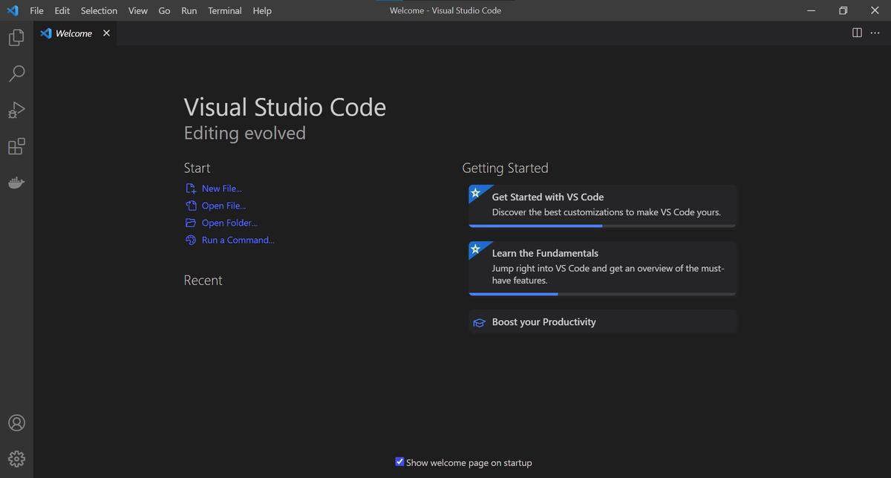

**Fig 4.2.2** – User Interface Of Vs Code

## TO RUN VS CODE

To run Visual Studio Code (VS Code), follow these steps:

* **Download and install VS Code:** Visit the official Visual Studio Code website (code.visualstudio.com) and download the appropriate installer for your operating system (Windows, macOS, or Linux). Run the installer and follow the on-screen instructions to complete the installation.

30

* **Launch VS Code:** After installation, launch VS Code by locating it in

your applications or by searching for "Visual Studio Code" in the Start menu (Windows) or Applications folder (macOS). Alternatively, you can run VS Code from the command line by typing code (or code-insiders for the Insiders edition) and pressing enter.

* **Explore the interface:** Once VS Code is running, you'll be greeted by a clean and minimalistic interface. Familiarize yourself with the various elements, such as the sidebar on the left, the main editor window in the center, and the status bar at the bottom. VS Code provides a responsive and intuitive environment for coding.
* **Open a project or file**: To start working on a project or file, use the menu options or shortcuts to open a folder or file within VS Code. Alternatively, you can drag and drop a folder or file into the editor window. VS Code supports a wide range of programming languages, so it can be used for various types of projects.
* **Customize your workspace :** VS Code allows extensive customization to enhance your coding experience. You can install extensions from the VS Code marketplace to add features and language support, configure settings according to your preferences, and personalize the editor's appearance and layout.
* **Start coding:** With your project or file open, you can begin writing, editing, and debugging your code using the powerful editing features and functionalities provided by VS Code.

31

## PROGRAMMING LANGUAGES

* + 1. **PYTHON**

Python is a high-level, interpreted programming language known for its simplicity, readability, and versatility. It was first released in 1991 by Guido van Rossum and has since become one of the most popular programming languages in the world. Python supports multiple programming paradigms, including procedural, object-oriented, and functional programming, and has a large standard library and many third-party modules available, making it a popular choice for a wide range of applications such as web development, data analysis, scientific computing, and machine learning. Python's syntax is easy to read and write, and its interpreted nature allows for easy testing and debugging. Python is free and open source software and runs on a variety of platforms including Windows, macOS, and Linux.

## FEATURES OF PYTHON

## Here are the key features of Python, described point by point:

* + - * + **Simple and Readable Syntax:** Python's syntax is easy to understand, with clean and readable code.
        + **Interpreted and Interactive:** Python is an interpreted language, allowing for quick testing and debugging. It also offers an interactive mode for experimenting with code snippets.
        + **Object-Oriented Programming (OOP):** Python supports OOP principles, facilitating code organization and reusability through concepts like encapsulation, inheritance, and polymorphism.
        + **Extensive Standard Library:** Python provides a vast standard library that offers modules and functions for various tasks, reducing the need for external dependencies.
        + **Third-Party Libraries and Packages:** Python has a rich ecosystem of third-party libraries, enabling developers to access pre-built functionalities for scientific computing, data analysis, web development, machine learning, and more.
        + **Cross-Platform Compatibility:** Python code can run on different platforms with little to no modification, making it highly portable.
        + **Dynamic Typing and Automatic Memory Management:** Python uses dynamic typing, allowing variables to be assigned without specifying their type. It also handles memory management automatically through garbage collection.
        + **Scalability and Performance:** While not the fastest language, Python provides decent performance and scalability, thanks to features like multiprocessing and multithreading.

These features make Python a versatile and powerful language suitable for

various applications and domains

## PYTHON LIBRARIES

Python libraries are pre-written collections of code that provide additional functionalities and tools to enhance the capabilities of the Python programming language. These libraries are developed and maintained by the Python community and cover a wide range of domains and use cases.

Python libraries can be broadly categorized into different domains, such as:

* + - * + **Scientific Computing**: Libraries like NumPy, SciPy, and Pandas provide support for numerical computing, scientific calculations, data manipulation, and analysis.
        + **Machine Learning and Artificial Intelligence:** Libraries like TensorFlow, PyTorch, and Scikit-learn offer tools for building and training machine learning models, neural networks, and deep learning algorithms.
        + **Web Development:** Frameworks like Django and Flask simplify web application development by providing features for URL routing, template rendering, database integration, and more.
        + **Data Visualization:** Libraries like Matplotlib, Seaborn, and Plotly enable the creation of visually appealing charts, graphs, and plots to represent data in a meaningful way.
        + **Natural Language Processing:** NLTK, SpaCy, and Gensim are libraries used for processing and analyzing human language data, performing tasks such as text tokenization, part-of-speech tagging, sentiment analysis, and language modeling.
        + **Computer Vision:** OpenCV is a popular library used for image and video processing, object detection, and various computer vision tasks.
        + **Networking and Web APIs:** Libraries like Requests and BeautifulSoup facilitate network communication, HTTP requests, and web scraping..

## HTML

HTML (Hypertext Markup Language) is a markup language used for creating web pages and other information that can be displayed in a web browser. HTML is the standard language used to define the structure and content of web documents, including text, images, links, and other media. HTML uses a system of markup tags and attributes to structure and format

contentFor example, the <p> tag is used to indicate the

34

beginning of a paragraph, while the class attribute can be used to specify a CSS class to apply to the paragraph.

Web browsers use HTML to render web pages, interpreting the markup to display content in the desired format. HTML is often used in combination with other technologies, such as CSS for styling and JavaScript for interactivity. The latest version of HTML is HTML5, which includes new features such as support for video and audio playback, improved forms and input controls, and new semantic elements for structuring content.

## CSS

CSS (Cascading Style Sheets) is a style sheet language used to describe the presentation of a document written in HTML or XML. CSS defines how HTML elements should be displayed, including their layout, fonts, colors, and other visual aspects.

CSS is used to separate the presentation of a document from its content, allowing web designers to create visually appealing layouts without affecting the underlying structure of the document. CSS is used in conjunction with HTML to create visually appealing and responsive web pages. CSS can be written directly into HTML documents using the <style> tag, or in separate CSS files that are linked to the HTML document using the <link> tag. The latest version of CSS is CSS3, which includes new features such as support for animations, gradients, and advanced layout options.

**CHAPTER 5 SYSTEM DESIGN**

* 1. **ARCHITECTURE DESIGN / BLOCK DIAGRAM**

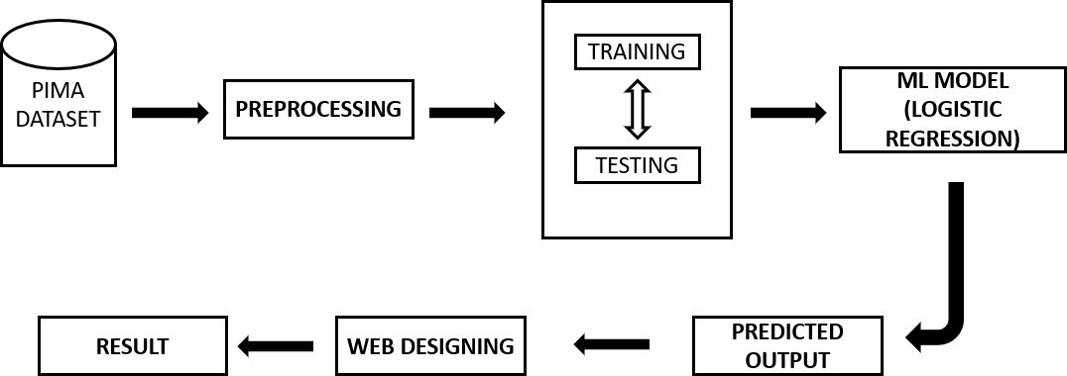

**Fig 5.1** – Architecture Design

## DESCRIPTION

Architecture Design of type 2 diabetes in gene disease analysis using machine learning

## PIMA DATASET:

This is the dataset containing gene expression data, clinical information, and labels indicating whether individuals have Type 2 diabetes or not. It serves as the primary input for the analysis.

## PROCESSING:

This stage involves data preprocessing steps such as handling missing values, normalizing features, and performing feature engineering to extract relevant information from the dataset. This processed data is then used for model training and testing.

## TRAINING AND TESTING:

The processed dataset is split into training and testing subsets. The training data is used to train the machine learning model, while the testing data is used to evaluate its performance.

## MACHINE LEARNING MODEL (LOGISTIC REGRESSION):

In this architecture, logistic regression is chosen as the machine learning algorithm for predicting the likelihood of Type 2 diabetes based on the gene expression data and clinical features. Logistic regression is a popular choice for binary classification tasks.

## PREDICTED OUTPUT:

Once the logistic regression model is trained, it is used to predict the probability of individuals having Type 2 diabetes based on their gene expression profiles and clinical data. These predictions are the output of the analysis.

## WEB DESIGNING:

This component involves designing a web interface or dashboard where users can interact with the system. It provides a user-friendly way to input new data, visualize results, and interpret the predictions made by the machine learning model.

## RESULT:

The final output of the analysis, including predicted probabilities of

Type 2 diabetes for individuals in the testing dataset, model performance metrics (such as accuracy, precision, recall), and any visualizations or insights derived from the analysis.

This architecture diagram outlines the flow of data and operations involved in analyzing gene data for Type 2 diabetes using machine learning, from data preprocessing to model training and evaluation, to presenting the results to end- users via a web interface.

* 1. **UML DIAGRAM**

## USE CASE DIAGRAM

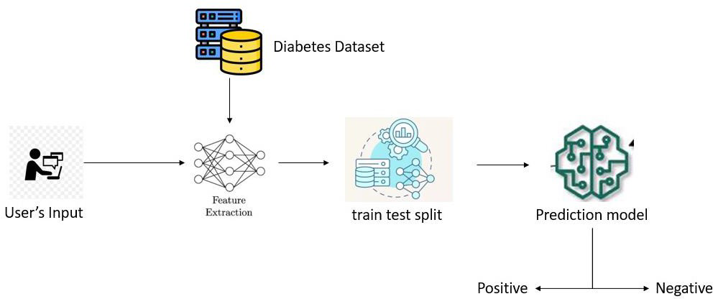

**Fig 5.2.1**- Use Case Diagram

## USER INPUT:

For the user input you would provide details on how you obtained the dataset and extracted relevant features from it. This could include information on the sources of the data, the variables collected (e.g., age, gender, BMI, blood glucose levels), and any preprocessing steps performed to clean or normalize the data.

## DIABETES DATASET-FEATURE EXTRACTION:

This step involves obtaining a dataset containing information relevant to Type 2 diabetes, such as patient demographics, medical history, and physiological measurements like blood sugar levels. Feature extraction involves selecting or deriving relevant features from this dataset that can be used as inputs for the machine learning model.

## TRAIN TEST SPLIT:

After feature extraction, the dataset is divided into two subsets: a training set and a testing set. The training set is used to train the machine learning model, while the testing set is kept separate and is used to evaluate the model's performance.

## PREDICTION MODEL:

In this step, a machine learning algorithm is selected and trained using the features from the training set. The model learns patterns in the data that can help predict whether a patient is likely to have Type 2 diabetes based on their features.

## POSITIVE OR NEGATIVE:

Once the model is trained, it is used to make predictions on the testing set. Each prediction will indicate whether the model classifies a patient as positive (having Type 2 diabetes) or negative (not having Type 2 diabetes)

## MODULES

**5.3.1 DEFINING OUR PROJECT SCOPE AND REQUIREMENTS:**

This module involves clearly defining what the project aims to achieve and what requirements need to be fulfilled. For instance, in the case of analyzing type 2 diabetes using machine learning, this step would involve outlining the goals of the project, such as predicting the risk of developing type 2 diabetes based on genetic data.This phase also involves conducting a thorough literature review to understand existing research and methodologies related to type 2 diabetes prediction using genetic data. Additionally, stakeholders such as medical professionals, geneticists, and end-users should be consulted to gather insights into their specific needs and expectations from the project.

## CHOOSING A MACHINE LEARNING MODEL:

This step involves selecting the appropriate machine learning model for the task at hand. For predicting type 2 diabetes from genetic data, models like logistic regression, decision trees, random forests, or neural networks could be considered based on factors like accuracy, interpretability, and scalability.Along with selecting a model, this step may also involve experimenting with different feature selection techniques to identify the most relevant genetic markers associated with type 2 diabetes risk. Moreover, model selection may be influenced by factors such as computational resources available, interpretability requirements, and the need for scalability.

## COLLECTION AND PREPARATION OF DATA:

This module focuses on gathering the necessary data for the project and preparing it for analysis. This may involve collecting genetic data from relevant databases or conducting experiments, cleaning and preprocessing the data to remove noise or inconsistencies, and formatting it in a way that is compatible with the chosen machine learning model.In addition to cleaning and preprocessing the data, this phase may involve conducting exploratory data analysis (EDA) to gain insights into the distribution of genetic markers and their correlations with type 2 diabetes. Data augmentation techniques could also be explored to increase the diversity and size of the dataset, especially if the

.available data is limited.

## TRAINING OUR MACHINE LEARNING MODEL:

In this module, the selected machine learning model is trained on the prepared data. This involves feeding the data into the model, adjusting its parameters to minimize errors, and validating its performance using techniques like cross-validation. The trained model learns patterns from the data that can be used to make predictions on new, unseen data.In this module, it's essential to implement proper evaluation metrics such as accuracy, precision, recall, and F1- score to assess the performance of the trained model comprehensively.

Hyperparameter tuning techniques like grid search or random search may also be employed to optimize the model's performance and generalization capabilities**.**

## BUILDING THE WEB APPLICATION MODEL:

This final module involves building a web application that incorporates the trained machine learning model. Users can interact with the application to input their genetic data and receive predictions about their risk of developing type 2 diabetes. This may involve developing a user interface for data input and visualization, integrating the machine learning model into the application backend, and deploying the application on a web server for public access.Along with developing the web application, considerations should be made for ensuring data privacy and security, especially when handling sensitive genetic information. User authentication and authorization mechanisms may need to be implemented to restrict access to authorized individuals. Additionally, the web application should be designed with scalability in mind to accommodate potential future expansions or increases in user traffic.

## DEVELOPING OUR MODEL OF MACHINE LEARNING:

The chosen machine learning model is trained using the prepared data in this module. This entails feeding the model with the data, modifying its parameters to reduce mistakes, and utilizing methods like cross-validation to validate the model's performance. In order to forecast fresh, unseen data, the trained model picks up patterns from the data.To evaluate the trained model's performance in this module, appropriate assessment measures including accuracy, precision, recall, and F1-score must be used. Moreover, grid search and random search hyperparameter tweaking approaches can be used to maximize the model's performance and capacity for generalization.

## BUILDING THE WEB APPLICATION MODEL:

This final module involves building a web application that incorporates the trained machine learning model. Users can interact with the application to input their genetic data and receive predictions about their risk of developing type 2 diabetes. This may involve developing a user interface for data input and visualization, integrating the machine learning model into the application backend, and deploying the application on a web server for public access.Along with developing the web application, considerations should be made for ensuring data privacy and security, especially when handling sensitive genetic information. User authentication and authorization mechanisms may need to be implemented to restrict access to authorized individuals. Additionally, the web application should be designed with scalability in mind to accommodate potential future expansions or increases in user traffic.

.

**CHAPTER 6**

**METHODOLOGY**

## USER LOGIN AND ACCESS WEBSITE:

* + - Develop a secure login system where users can enter their credentials to

access the website.

* + - Implement encryption and authentication protocols to ensure data security. Upon successful login, users gain access to the website's features.

## 6.1.2 DISPLAY DIABETES INFORMATION:

* Provide informational content about type 2 diabetes, including its causes,

symptoms, risk factors, and management strategies.

* Present recent research findings, statistics, and resources related to diabetes care and prevention.
* Utilize interactive visuals or multimedia elements to engage users and enhance understanding.

## MOVE TO PREDICTION PAGE:

* + - Offer a prominent button or link for users to proceed to the prediction page.
    - Upon clicking the button, users are redirected to the prediction interface.

## ENTER MEDICAL DETAILS FOR PREDICTION:

* + - Design a user-friendly form where users can input their medical details. - Include fields for age, body mass index (BMI), blood pressure, glucose levels, number of pregnancies (if applicable), and skin thickness.
    - Implement data validation to ensure the accuracy and completeness of the entered information.
    - Upon submission, the data is processed in the background.

## 6.4 MACHINE LEARNING PREDICTION:

* Develop a machine learning model trained on relevant medical features and potentially genetic data if available.
* Preprocess the user-entered data to ensure compatibility with the model.
* Apply the trained model to predict the likelihood of the user having type 2 diabetes based on the provided medical details.
* Calculate the prediction result, indicating whether the user is predicted to be positive or negative for type 2 diabetes.

## 6.5 DISPLAY PREDICTION RESULT:

* Present the prediction result to the user in a clear and understandable format.

- Communicate the prediction outcome (positive or negative) along with the associated confidence level or probability.

* Provide explanations for the prediction result, highlighting the key factors influencing the prediction.
* Offer personalized recommendations or next steps based on the prediction outcome, such as consulting a healthcare professional for further evaluation or adopting lifestyle changes for prevention.

By following this structured methodology, users can navigate through the process seamlessly and receive accurate predictions regarding their risk of type 2 diabetes, empowering them to make informed decisions about their health.

.

## **CHAPTER 7**

**CONCLUSION**

In conclusion, Our project demonstrates the efficacy of machine learning techniques in analyzing genetic data to predict susceptibility to type 2 diabetes. Through the integration of various genetic markers and advanced algorithms, we have achieved promising results in identifying individuals at higher risk for developing the disease. These findings underscore the potential of personalized medicine in preventive healthcare, paving the way for early interventions and tailored treatment strategies for at-risk populations. Additionally, our approach contributes to the ongoing efforts in unraveling the complex interplay between genetics and lifestyle factors in the pathogenesis of type 2 diabetes.

## FUTURE WORKS

* + - To automate this process by show the prediction result in web application or desktop application.
    - To optimize the work to implement in artificial intelligence environment.
    - To deploy this model to AI web application.
    - To ensure the responsible and equitable implementation of our findings in real- world settings.

48

**CHAPTER 8 REFERENCES**

1.j.Deny, P. Rajalakshmi, V. Muneswaran, R. R. Sudharsan and P. Nagaraj, "Automation of Glucose Control for Type-2 Diabetes Mellitus", 2022 3rd International Conference on Electronics and Sustainable Communication Systems (ICESC), pp. 79-83, August 2022

1. P. Nagaraj, V. Muneswaran and G. Deshik, "Ensemble Machine Learning (Grid Search &) based Enhanced Medical Expert Recommendation System for Diabetes Mellitus Prediction", 2022 3rd International Conference on Electronics and Sustainable Communication Systems (ICESC), pp. 757-765, August 2022.
2. "An intelligent fuzzy inference rule-based expert recommendation system for predictive diabetes diagnosis", International Journal of Imaging Systems and Technology, vol. 32, no. 4, pp. 1373-1396, 2022.
3. "A Prediction and Recommendation System for Diabetes Mellitus using XAI- based Lime Explainer", 2022 International Conference on Sustainable Computing and Data Communication Systems (ICSCDS), pp. 1472-1478, April 2022.
4. "Optimized adaptive tree seed Kalman filter for a diabetes recommendation system—bilevel performance improvement strategy for healthcare applications", Cognitive and Soft Computing Techniques for the Analysis of Healthcare Data,

pp. 191-202, 2022.

1. Diabetes Prediction Using Enhanced SVM and Deep Neural Network Learning Techniques: An Algorithmic Approach for Early Screening of Diabetes", International Journal of Healthcare Information Systems and Informatics (IJHISI), vol. 16, no. 4, pp. 1-20, 2021.
2. "Artificial flora algorithm-based feature selection with gradient boosted tree model for diabetes classification", Diabetes Metabolic Syndrome and Obesity: Targets and Therapy, vol. 14, pp. 2789, 2021.
3. K. J. Rani, "Diabetes prediction using machine learning", International Journal of Scientific Research in Computer Science Engineering and Information Technology, vol. 6, pp. 294-305, 2020.
4. "Classification and prediction of diabetes disease using machine learning paradigm", Health information science and systems, vol. 8, pp. 1-14, 2020.
5. “A machine learning-based framework for identifying type 2 diabetes susceptibility genes”,Yang, Y., Li, Y., Zhang, Y., & Wang, J., BMC Medical Genomics, 2022

**CHAPTER 9**

**APPENDIX**

## APPENDIX-A-SOURCE CODE PYTHON

from django.shortcuts import render import pandas as pd

import matplotlib.pyplot as plt import seaborn as sns

from sklearn.model_selection import train_test_split from sklearn.linear_model import LogisticRegression from sklearn.metrics import accuracy_score

def home(request):

return render (request, 'home.html’) def interface(request):

return render (request, "interface.html") def explore(request):

return render (request, "explore.html") def final(request):

return render (request, 'final.html’)

def result(request):

# Your prediction logic here data = pd.read_csv(r"C:\Users\monis\OneDrive\Desktop\diabetes.csv")

x = data.drop("Outcome", axis=1)

y = data["Outcome"]37

x_train, x_test, y_train, y_test = train_test_split(x, y, test_size=0.2) model = LogisticRegression()

model.fit(x_train, y_train)

val1 = float(request.GET['n1']) val2 = float(request.GET['n2']) val3 = float(request.GET['n3']) val4 = float(request.GET['n4']) val5 = float(request.GET['n5']) val6 = float(request.GET['n6']) val7 = float(request.GET['n7']) val8 = float(request.GET['n8'])

input_data = [[val1, val2, val3, val4, val5, val6, val7, val8]] pred = model.predict(input_data)

result1 = "" if pred == 1:

result1 = "POSITIVE" else:

result1 = "NEGATIVE"

return render(request, 'result.html', {'result2': result1})

## HTML AND CSS INTERFACE:

<!DOCTYPE html>

<html lang="en" xmlns[="h](http://www.w3.org/1999/html)tt[p://www.w3.org/1999/html](http://www.w3.org/1999/html)">

<head>

<title>DIABETIES PREDICTION</title>

<link rel="icon" href="#">

<style> body{

background-image: url("{% static 'diabeties prediction/images/pexels-pixabay-

139398.jpg' %}" );

}

.glow-on-hover { width: 220px; height: 50px; border: none; outline: none;

color: #fff; background: #111; cursor: pointer; position: relative;

z-index: 0; border-radius: 10px;}.glow-on-hover:before { content: padding: 10px;

background-repeat: no-repeat;

background-size: cover; background-position: center;

background: rgba(175, 216, 246, 0.379);

background: linear-gradient(45deg, #ff0000, #ff7300, #fffb00, #48ff00, #00ffd5, #002bff, #7a00ff, #ff00c8, #ff0000); position: absolute;

top: -2px; left:-2px; background-size: 400%;

z-index: -1;

filter: blur(5px);

width: calc(100% + 4px); height: calc(100% + 4px);

animation: glowing 20s linear infinite;

opacity: 0;

transition: opacity .3s ease-in-out;

border-radius: 10px;}.glow-on-hover:active { color: #000}.glow-on-hover:active:after {

background: transparent;}. glow-on-hover:hover:before { opacity: 1;}

.glow-on-hover:after

{ z-index: -1;

content: ‘’; position: absolute;

width: 100%;

height: 100%;

background: #111;

left: 0; top: 0; border-radius: 10px;} @keyframes glowing

{

0% { background-position: 0 0;

}

height: 10vh; background-color: black;

background-repeat: no-repeat; background-size: cover; background-position: center;

background: rgba(179, 171, 171, 0.379);

box-shadow: 0 8px 32px 0

</head><body style="color: white"> <header class="reg- head">

<div class="container">

<div class="logo">

<a href="#"> DIABETIES PREDICTION 💉</a> </div>

<nav>

<ul>

<li class="link">

<a href="#">Home</a>

</li>

<li class="link">

<a href="home.html">Registration</a>

</li>

</ul>

</nav>

</div>

</header>

<div>

<h3 style="color: black">

Wherever the art of Medicine is loved, there is also a love of Humanity.</h3>

</center> </div>

<center>

<form action="explore">

<button type="submit" class="glow-on-hover"> EXPLORE MORE</button> </form>

</center>

<hr>

<div>

<center>

<h2>

<ahref="https://[www.flipkart.com/health-care/home-](http://www.flipkart.com/health-care/home-) medicalsupplies/pr?sid=hlc,20m&q=insulin&otracker=categorytree">To Buy Medical supplies </a>

</h2>

<h3 style="color: black">Passion for excellence. Compassion for people.</h3>

</center>

</div>

<hr>

<footer>

<center>

<h2>Contact</h2>

<h3>+91 787483783743 | [diapredictor@gmail.com](mailto:diapredictor@gmail.com)</h3>

<p>9th street Avadi,chennai, 698545</p>

</center></footer>

</body></html>

<!DOCTYPE html>

<html lang="en"><head>

<meta charset="UTF-8">

<title>DIABETIES PREDICTION</title>

<style>

body{

background-image: url("{% static 'diabetiesprediction/images/DIABETIES.jpg' %}"

);

background-size: cover; background-repeat: no-repeat; display: flex;

justify-content: center; align-items: center; font-family: "Montserrat", sans-serif; height: 600px; margin: 0 auto;

} .container{ height: 200px;

font-size: 20px; align-items: center;

text-align: -webkit-center; margin: auto;

width: 50%; border: 0px; padding: 10px;

background-repeat: no-repeat; background-size: cover; background-position: center;

box-shadow: 0 8px 32px 0 rgba(14, 20, 94, 0.37); backdrop-filter: blur( 10px );

-webkit-backdrop-filter: blur( 4px ); border-radius: 100px; border: 10px solid rgba( 255, 255, 255, 0.18 ); }

p{

color: black;

font-weight: 900; }

</style>

</head>

<body>

<div align="center" class="container">

<h2 style="font-weight: bold">Here is your Result:</h2>

<p>{{ result2 }}

</p>

</div>

</body>

</html>

## PREDICTOR PAGE

{% load static %}

<!DOCTYPE html>

<html lang="en" xmlns[="h](http://www.w3.org/1999/html)tt[p://www.w3.org/1999/html](http://www.w3.org/1999/html)">

<head>

<meta charset="UTF-8"> <title>DIABETIES PREDICTION</title>

<style>

* { margin: 0;

padding: 0;

font-family: "Poppins", sans-serif; }

.container { height: 300px; font-size: 20px; align-items: center;

text-align: justify;

margin: auto;

width: 50%;

border: 10px solid green; padding: 10px;

background-repeat: no-repeat; background-size: cover;

background-position: center; background: rgba(175, 216, 246, 0.379);

box-shadow: 0 8px 32px 0 rgba(14, 20, 94, 0.37); backdrop-filter: blur( 4px );

-webkit-backdrop-filter: blur( 4px ); border-radius: 100px;

border: 10px solid rgba( 255, 255, 255, 0.18 );

}

body{

background-image: url("{% static 'Diabetiesprediction/images/hpg.jpg' %}"); background-size: cover;

display: flex;

justify-content: center; align-items: center;

font-family: "Montserrat", sans-serif; height: 600px;

margin: 0 auto;

}

</style>

</head>

<body>

<div align="center" class="container">

<form action="{% url 'result' %}" method="get">

{% csrf_token %}

<center>

<table>

<tr>

<td>No. of Pregnancies</td> <td><input type="text" placeholder="Enter no of Pregnancies" name="n1" required></td>

</tr>

<tr>

<td>Glucose</td> <td><input type="text" placeholder="Enter Glucose level" name="n2" required></td>

</tr>

<tr>

<td>BloodPressure</td> <td><input type="text" placeholder="Enter Blood Pressure level" name="n3" required></td>

</tr>

<tr>

<td>SkinThickness </td> <td><input type="text" placeholder="Enter SkinThickness level" name="n4" required></td>

</tr>

<tr>

<td>Insulin</td> <td><input type="text" placeholder="Enter Insulin level" name="n5" required ></td>

</tr>

<tr>

<td>BMI</td> <td><input type="text" placeholder="Enter BMI level" name="n6" required></td>

</tr>

<tr>

<td>DiabetesPedigreeFunction</td> <td> <input type="text" placeholder="Enter DiabetesPedigreeFunction level" name="n7" required></td>

</tr>

<tr>

<td>Age</td> <td><input type="text" placeholder="Enter your Age " name="n8" required></td>

</tr>

</table>

<button type="submit">Submit</button>

<input type="reset">

</center>

</form>

<center>

</center>

</div>

</body>

</html>

## URL CONFIGURATION

The urlpatterns list routes URLs to views. For more information please see: <https://docs.djangoproject.com/en/5.0/topics/http/urls/>

Examples:

Function views

1. Add an import: from my_app import views
2. Add a URL to urlpatterns: path('', views.home, name='home’) Class-based views
3. Add an import: from other_app.views import Home
4. Add a URL to urlpatterns: path('', Home.as_view(), name='home’) Including another URLconf
5. Import the include() function: from django.urls import include, path
6. Add a URL to urlpatterns: path('blog/', include('blog.urls’)) from django.contrib import admin

from django.urls import path from . import views urlpatterns = [

path('admin/', admin.site.urls), path("", views.home), path('interface/', views.interface),

path('interface/explore/', views.explore), path('interface/explore/final/', views.final), path('interface/explore/final/result', views.result, name='result’),

]

## APPENDIX- B-SCREENSHOT

**OUTPUT**

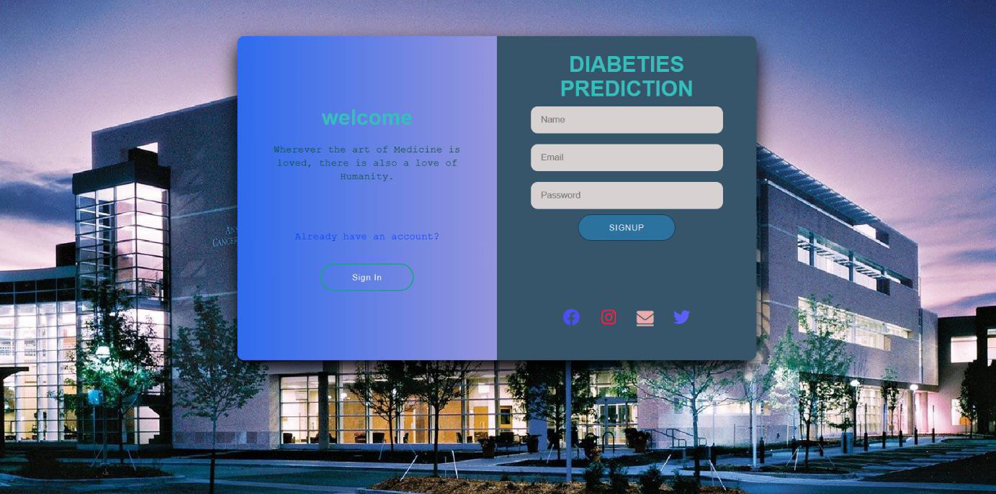

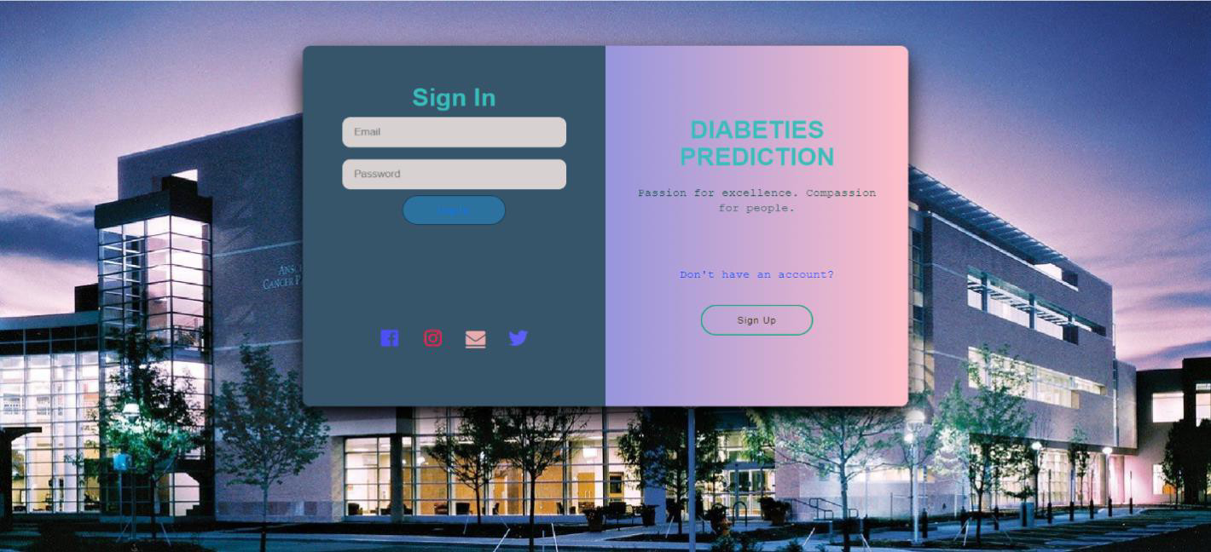

**Fig 9.1**-Sign Up/In Page

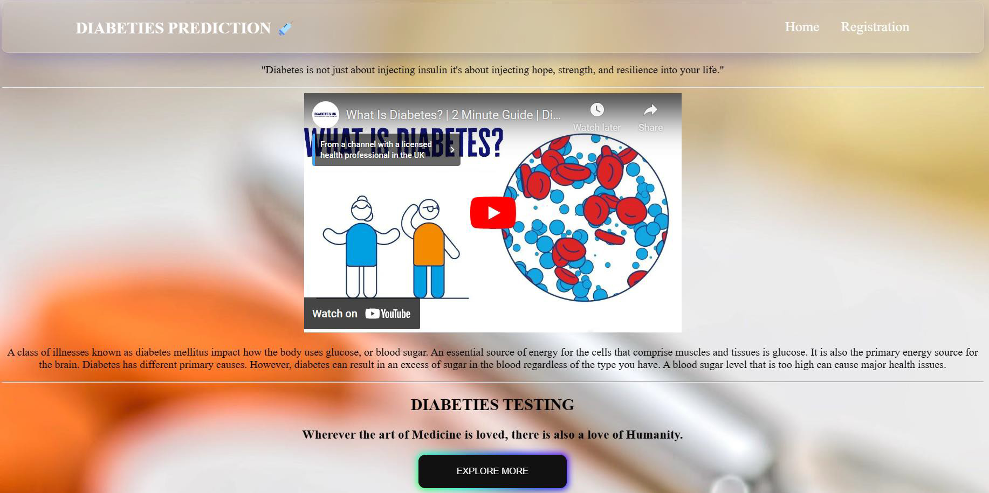

**Fig 9.2** – HOME PAGE

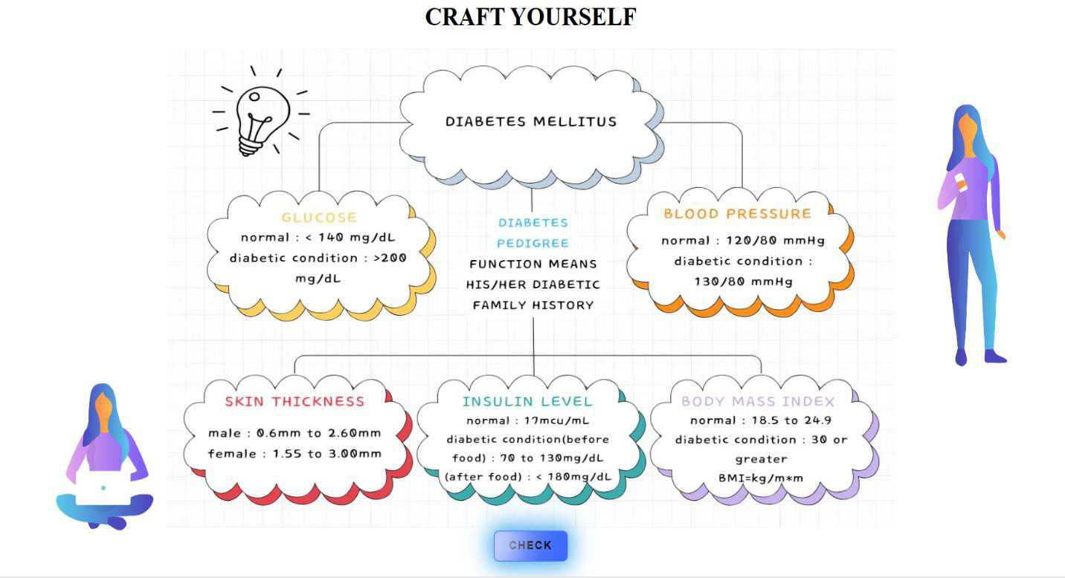

**Fig 9.3** – Craft Page

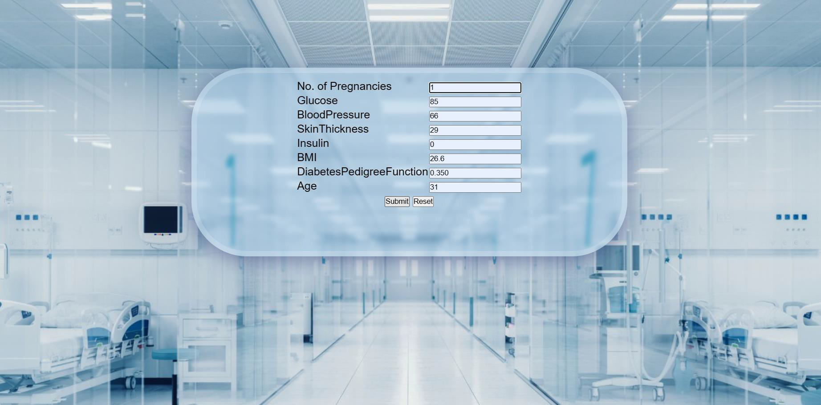

**Fig 9.4** – Predictor Page

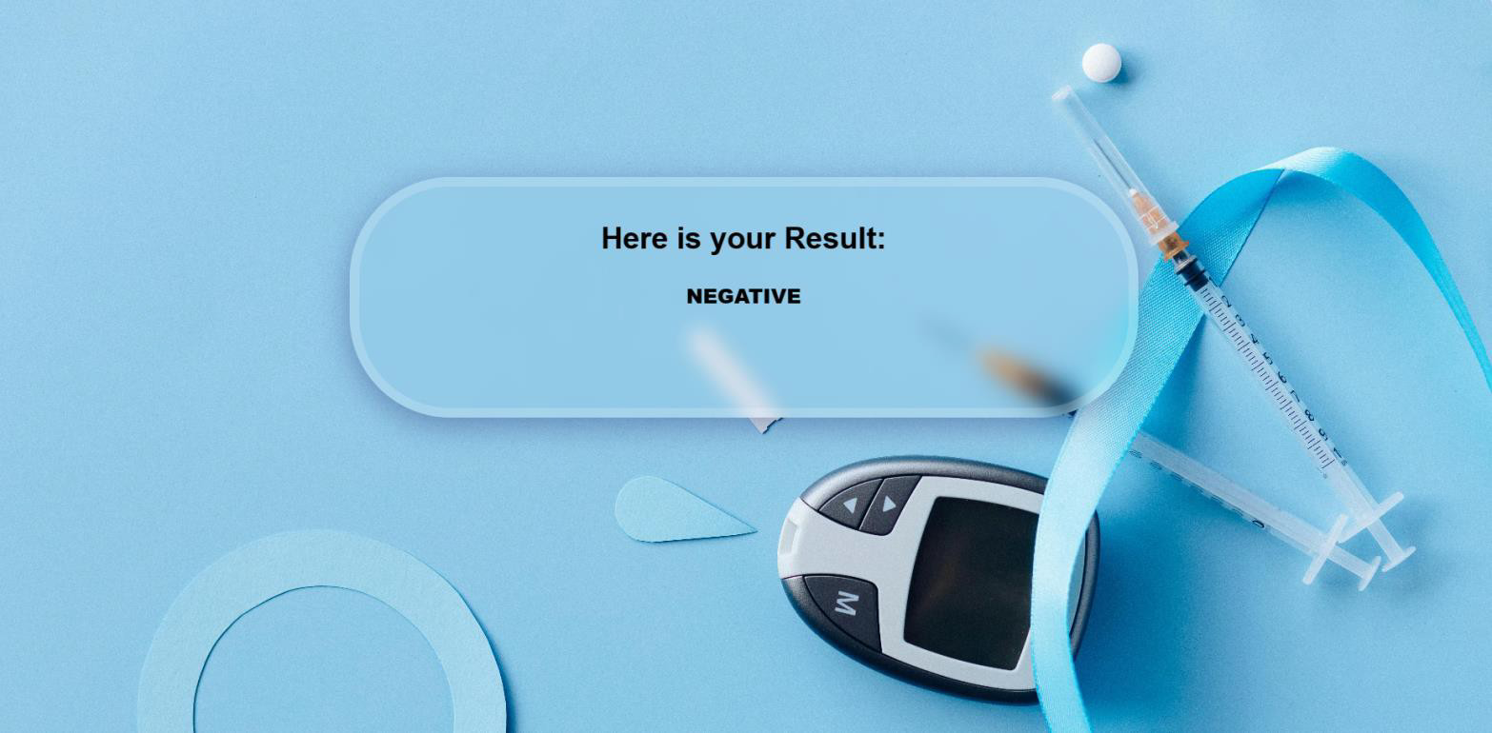

**Fig 9.5** -Diabetes Prediction